RECLAIMED WATER AND THE SPRING CREEK GOLF COURSE
“Water…..it’s too valuable to be used just once”
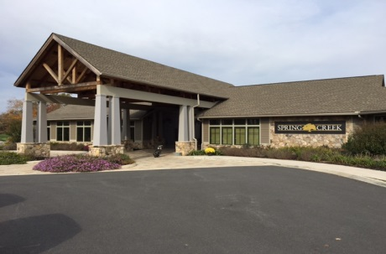
The Louisa County Water Authority (LCWA) and Spring Creek Associates, LLC partnered in 2014 to use the treated “Level 1 Reclaimed Effluent” from the Zion Crossroads Wastewater Treatment Plant (WWTP) located in the Spring Creek subdivision for irrigation of the golf course greens and shrubs in an effort to conserve drinking water use in the Zion Crossroads area.
What is reclaimed water?

Wastewater isn’t just water from toilets. It comes from many sources in the home, including washing machines, sinks, and showers, as well as from commercial and industrial processes. Wastewater recycling replicates the natural processes to offer an environmentally sound and cost-effective way to remove the waste and reclaim that water.

Reclaimed water is wastewater that has undergone advanced treatment and disinfection to remove bacteria and other harmful substances so that it can be beneficially reused. Reclaimed water, often referred to as “reuse,” is safe for uses such as the irrigation of lawns, golf courses or landscaping. It can also be used for aesthetic water features, to recharge the aquifer, and to help restore natural areas.

Why conserve or reuse water?
Some areas of the United States have abundant supplies of quality water that meet year-round needs. Other areas have a limited supply of acceptable water and need to conserve. In Louisa County, our area has seen several severe droughts during the summer months (peak demand months for water use) over the last few years that caused the issuance of water restrictions and requests to conserve water voluntarily. By using reclaimed water for golf course irrigation the strain on the ground water supply during a drought is reduced and water is available for public use. The need for water conservation becomes more important as populations increase and with it the demand for more drinking water.
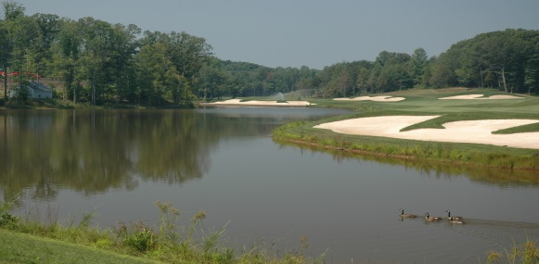
How does the use of reclaimed water benefit our environment?

Using reclaimed water for irrigation and other purposes saves our drinking water, which is a precious, limited resource. Because of the small amounts of nutrients contained in reclaimed water, it also decreases the amount of fertilizer used on golf courses, lawns and in landscaping. For more than 30 years, reclaimed water has been safely used throughout the country in recreational lakes, sprinkler systems for homes and businesses, crop irrigation and manufacturing processes. Since reclaimed water is used for non-drinking purposes, a separate set of distribution pipelines has been built to deliver reclaimed water from the Zion Crossroads Wastewater Treatment Plant to an impoundment located in Spring Creek. Water is withdrawn from the impoundment by the Spring Creek Golf Course irrigation system and is used on the course during the spring, summer and fall seasons. Approximately 129,518,072 million gallons of reclaimed water have been used to irrigate the golf course to date (2016 thru 2022). The amount of reclaimed water used on the golf course will continue to increase well into the future.

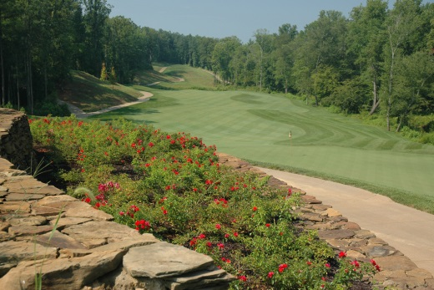

How does the golf course and thus homeowners benefit from using reclaimed water?

Reclaimed water provides a reliable source of irrigation water at a lower cost than drinking water. It provides nutrients to the golf course and surrounding landscape, which reduces the amount of fertilizer applied per year to the course. Reclaimed water indirectly provides water for wetlands, streams, ponds and lakes typically seen around golf courses and it provides an environmentally sound asset to the community by providing reclaimed water for the golf course.

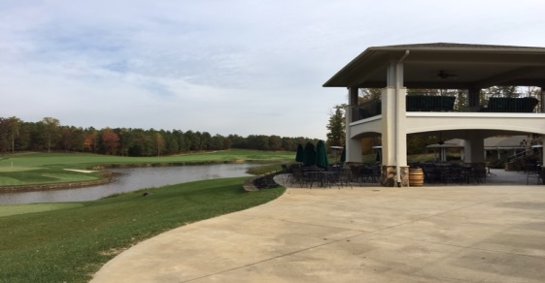

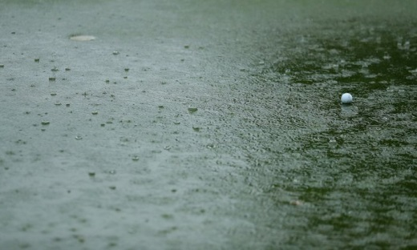
We take our cue from Mother Nature to create clean recycled water.

When it comes to recycling wastewater, no one is a better teacher than Mother Nature. After all, she’s been doing it since the beginning of time through her own purification system of lakes, streams, and rivers. The Zion Crossroads WWTP plant literally replicates what happens in nature. We just speed up the process and do it in a modern, high-tech facility. As the population grows, so does the need for new sources of water. Next to water conservation, water recycling is the only significant “new” source of water that can meet the domestic, industrial, and environmental demands that are increasing on a daily basis. Using partially treated water (effluent) from a nearby wastewater treatment facility is a creative, environmentally sound way to meet irrigation needs. Treated wastewater contains low levels of nutrients, salts, heavy metals, and bacteria and is therefore not potable. Rather than discharging this water into streams, the conventional method for disposal, water can be irrigated (at appropriate rates), and used by the turf for moisture and nutrients needs. The water trickles down into the soil where other contaminants can be broken down. Golfers should not notice a difference in play while on the course.

A promising future:
The evolution of proper sanitary practices, including wastewater management, has virtually eliminated water-borne disease in the United States and contributed to a longer life expectancy. The Zion Crossroads WWTP is at the forefront of technology that ensures public health and safety. Years of ongoing testing and monitoring have shown that the Zion Crossroads WWTP tertiary-treated reclaimed water is virtually free of pathogenic viruses, meets strict federal and state reuse water standards, and is a very clean reclaimed water source. The Louisa County Water Authority (LCWA) continues to strive to provide the Spring Creek golf course with the best possible reclaimed water for golf course irrigation. That’s good news for Zion Crossroads residents, where the water supply must serve a population that is increasing, knowing that future droughts will continue to reduce fresh water reserves. The Zion Crossroads WWTP’s ability to replicate the natural biological process through state-of-the-art technologies ensures that LCWA can help the region meet its growing needs for a safe and reliable water supply by reducing the demand on drinking water through reclaimed water reuse.

Are there any public safety
concerns using reclaimed water?

There are extensive rules and regulations covering reclaimed water usage. These include proper signage and making sure all pipes, meter boxes and other irrigation equipment are properly marked or color-coded purple to distinguish them from potable supplies and avoid any potential for cross-connections.

Although reclaimed water is fully disinfected, it is not intended for human consumption or for activities such as swimming or showering. Incidental contact with reclaimed water, such as being splashed or sprayed by a sprinkler, is safe for people and animals. Strict rules are followed to ensure that reclaimed water is disinfected properly and not accidentally consumed or interconnected with the drinking water system.

Contact Information:

If you have any questions regarding reclaimed water and its use in Louisa County please contact the Louisa County Water Authority (LCWA). We will be happy to discuss reclaimed water with you.

Louisa County Water Authority
23 Loudin Lane
Louisa, VA 23093

(540) 967-1122

